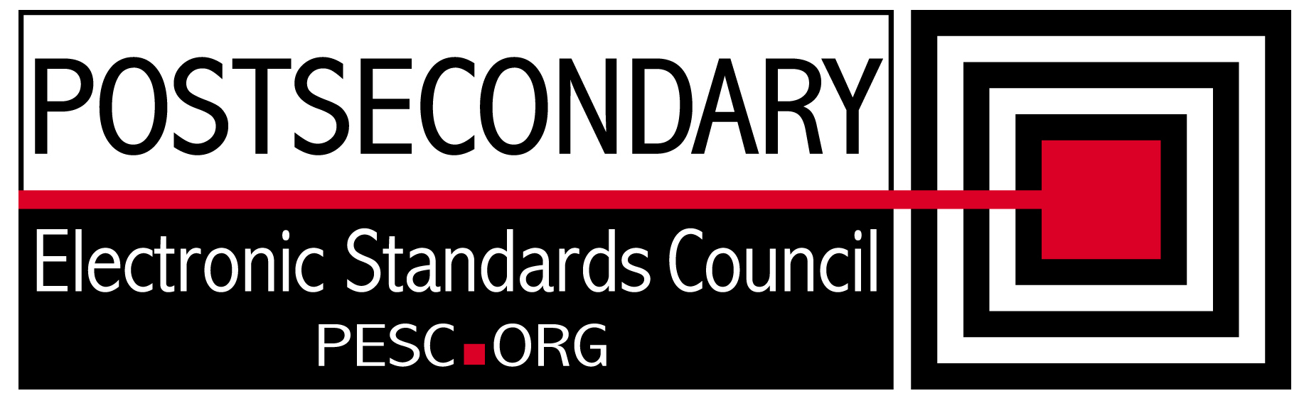

Standards Forum for Education
Status Update Form

Workgroup/Board Group Name | Technical Advisory Board
General Summary of Status | Made progress on R&R and edu1world
Status Flag (Red/Yellow/Green) | Green
Report Data | 1/14/2011
Projected Completion Date | Standing PESC Board

Item | Responsible Resource | Status  (Report update status of Deliverable/Objective  since last report)
Planned Deliverables/Objectives
(Provide at least 3)
Component Architecture: Single file schema | Morris/TAB | Discussed single file schema approach with PESC Board. Demonstrated R&R to Board
Edu1world approach | Sanstra/TAB | Continuing to use edu1world for all TAB activities
CEDS integration approach | Cameron/TAB | Attending meetings and gathering information for participation
SIF synchronization | TAB | Discussed approaches with PESC Board
Data Transport Specification | TAB | No activity
Language Support | Hamidi/TAB | Found experts from W3C who have agreed to attend a future meeting
Open Source approach | Hamidi/TAB | Reviewed Java library and created an instance document with the tool. Promising approach
Accomplishments/
Completions
Actively using edu1world for board activities | TAB | Reporting file issues to Lauren Piper. All agendas and meeting notes kept on site
Completed Review of R&R and issues needing to be resolved | TAB
Presented R&R to the PESC Board | Morris
Created Schema using College Transcript Java Files | Morris
Issues/Obstacles
SIF / PESC common approach | TAB | Do not have a coherent strategy for synchronizing PESC and SIF. Approaches are very different and will require significant changes in process and architecture for PESC
Registry and Repository | Morris  Sue Lou(FSA) | PESC schema practices are not compatible with the current structure of the R&R. TAB is reviewing issues
Meetings/Calls Since Last Update | 2

Note: Chairs and/or leaders of workgroups, boards and committees under The Standards Forum for Education are required to provide updates during the Steering Committee’s monthly conference call meeting held the second Friday each month at 2:00pm EST. Call in information is: 866-352-3799 *7696363*. Forms must be completed and submitted prior to meeting time. Forms may also be posted on the PESC website as needed to provide the community at-large with a means to obtain updates for ongoing, but yet to-be-completed development efforts.

To add rows to table, click outside of the table, to the right on the row where you want to add another row . With cursor blinking, hit the enter key. A new row will be inserted.

